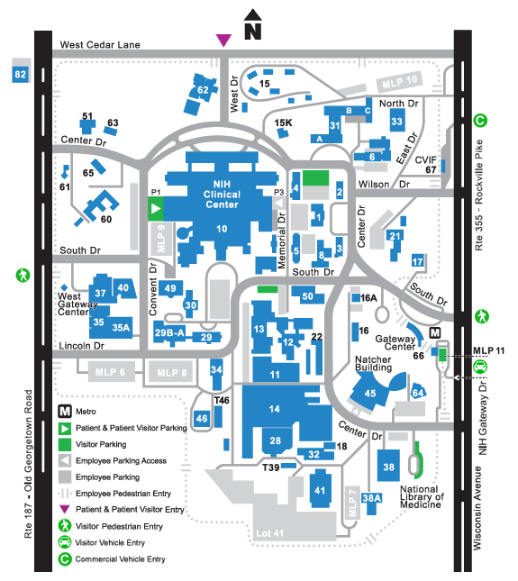

**Main Visitor Entrance**

NIH Visitor Parking